Coupled Multi-Layer Attentions

for Co-Extraction of Aspect and Opinion Terms

The task of aspect and opinion terms co-extraction aims to explicitly extract aspect terms describing features of an entity and opinion terms expressing emotions from user-generated texts. To achieve this task, one effective approach is to exploit relations between aspect terms and opinion terms by parsing syntactic structure for each sentence. However, this approach requires expensive effort for parsing and highly depends on the quality of the parsing results. In this paper, we offer a novel deep learning model, named coupled multi-layer attentions. The proposed model provides an end-to-end solution and does not require any parsers or other linguistic resources

for preprocessing. Specifically, the proposed model is a multilayer attention network, where each layer consists of a couple of attentions with tensor operators. One attention is for extracting aspect terms, while the other is for extracting opinion terms. They are learned interactively to dually propagate information between aspect terms and opinion terms.

Introduction

An aspect term refers to a word or a phrase (a sequence of words) describing an attribute or feature of an entity, e.g., a product. An opinion term refers to the expression carrying subjective emotions.

In summary, our contributions are two-fold: 1) We propose an end-to-end deep learning model for aspect and opinion terms co-extraction without requiring any syntactic dependency parsers or linguistic resources to generate additional information as input. 2) We conduct extensive experiments on three benchmark datasets to verify that our model achieves state-of-the-art performance for aspect and opinion terms co-extraction.

Related Work

Aspect and Opinion Terms Extraction

Attention & Memory Network

The attention mechanism aims to select and attend to relevant parts of the input which could be thought of as a soft-alignment process. A memory network generally consists of multiple layers of attentions, which has shown superior performance in many NLP tasks.

Problem Statement & Motivation

Therefore, in this paper, we offer an end-to-end deep learning model, which models the relations among tokens automatically without any dependency parsing or feature engineering, and achieves state-of-the-art performances for aspect and opinion terms co-extraction.

Coupled Multi-layer Attentions

For each sentence, we construct a pair of attentions, one for aspect terms extraction, and the other for opinion terms extraction.

The pair of attentions are coupled in learning such that the learning of each attention is affected by the other. This helps to double-propagate information between them.

To further capture indirect relations among aspect and opinion terms, we construct a network with multiple layers of coupled attentions.

Attention with Tensor Operator

A basic unit of CMLA is a pair of attentions: aspect attention and opinion attention. The weight of each input unit is an attention score obtained from its composition with a prototype vector which guides the model about where to attend.

Coupled Attentions for Dual Propagation

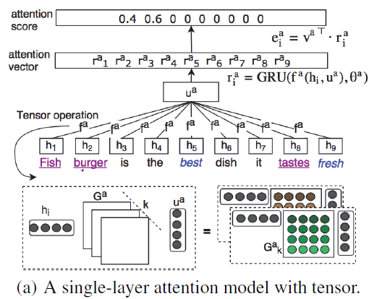

Multi-Layer Coupled Attentions

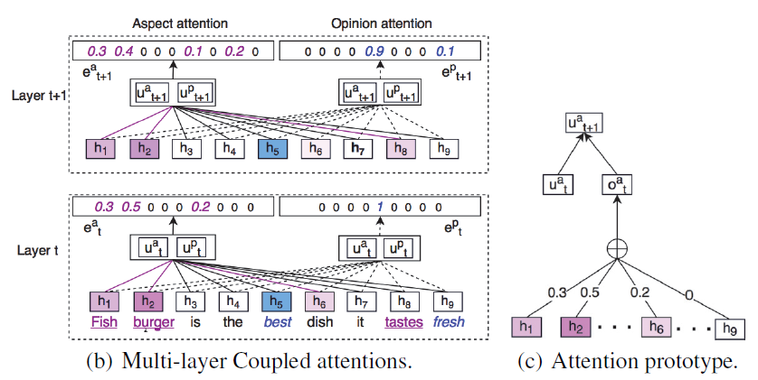

Experiments

Experimental Results

Conclusion

We present a novel end-to-end network with coupled multilayer attentions, CMLA, for aspect-opinion co-extraction, which does not require any parsers or linguistic resources. Different from traditional attention network, we propose coupled attentions to exploit the correlations among input tokens, especially between aspect and opinion terms, through tensor operators. Moreover, the multi-layer structure helps to extract non-obvious targets with indirect relations.